# Module 3 Activity 1

# Brandon Trinkle

# IFT 458: Middleware Prog & Database Sec

# Professor: Dinesh Sthapit

# Feb 7, 2025

# Module 3 Activity 1

1. *Screenshot 1: of the email confirmation from MongoDB Atlas.*

1. *Screenshot 2: of the new project setup.*

1. *Screenshot 3: of the new cluster in MongoDB Atlas.*

1. *Screenshot 4: of the database and collections (the student can blur or hide sensitive data).*

1. *Screenshot 5: of the connection IP and user setup.*

*Note: I did not capture a screenshot when setting up my user account that showed IP address. However, here is a screenshot showing that my user account has access to the project, cluster and collection I created.*

1. *Screenshot 6: of the connection string (the student should blur out sensitive parts like username and password).*

*Connection to MongoDB:  
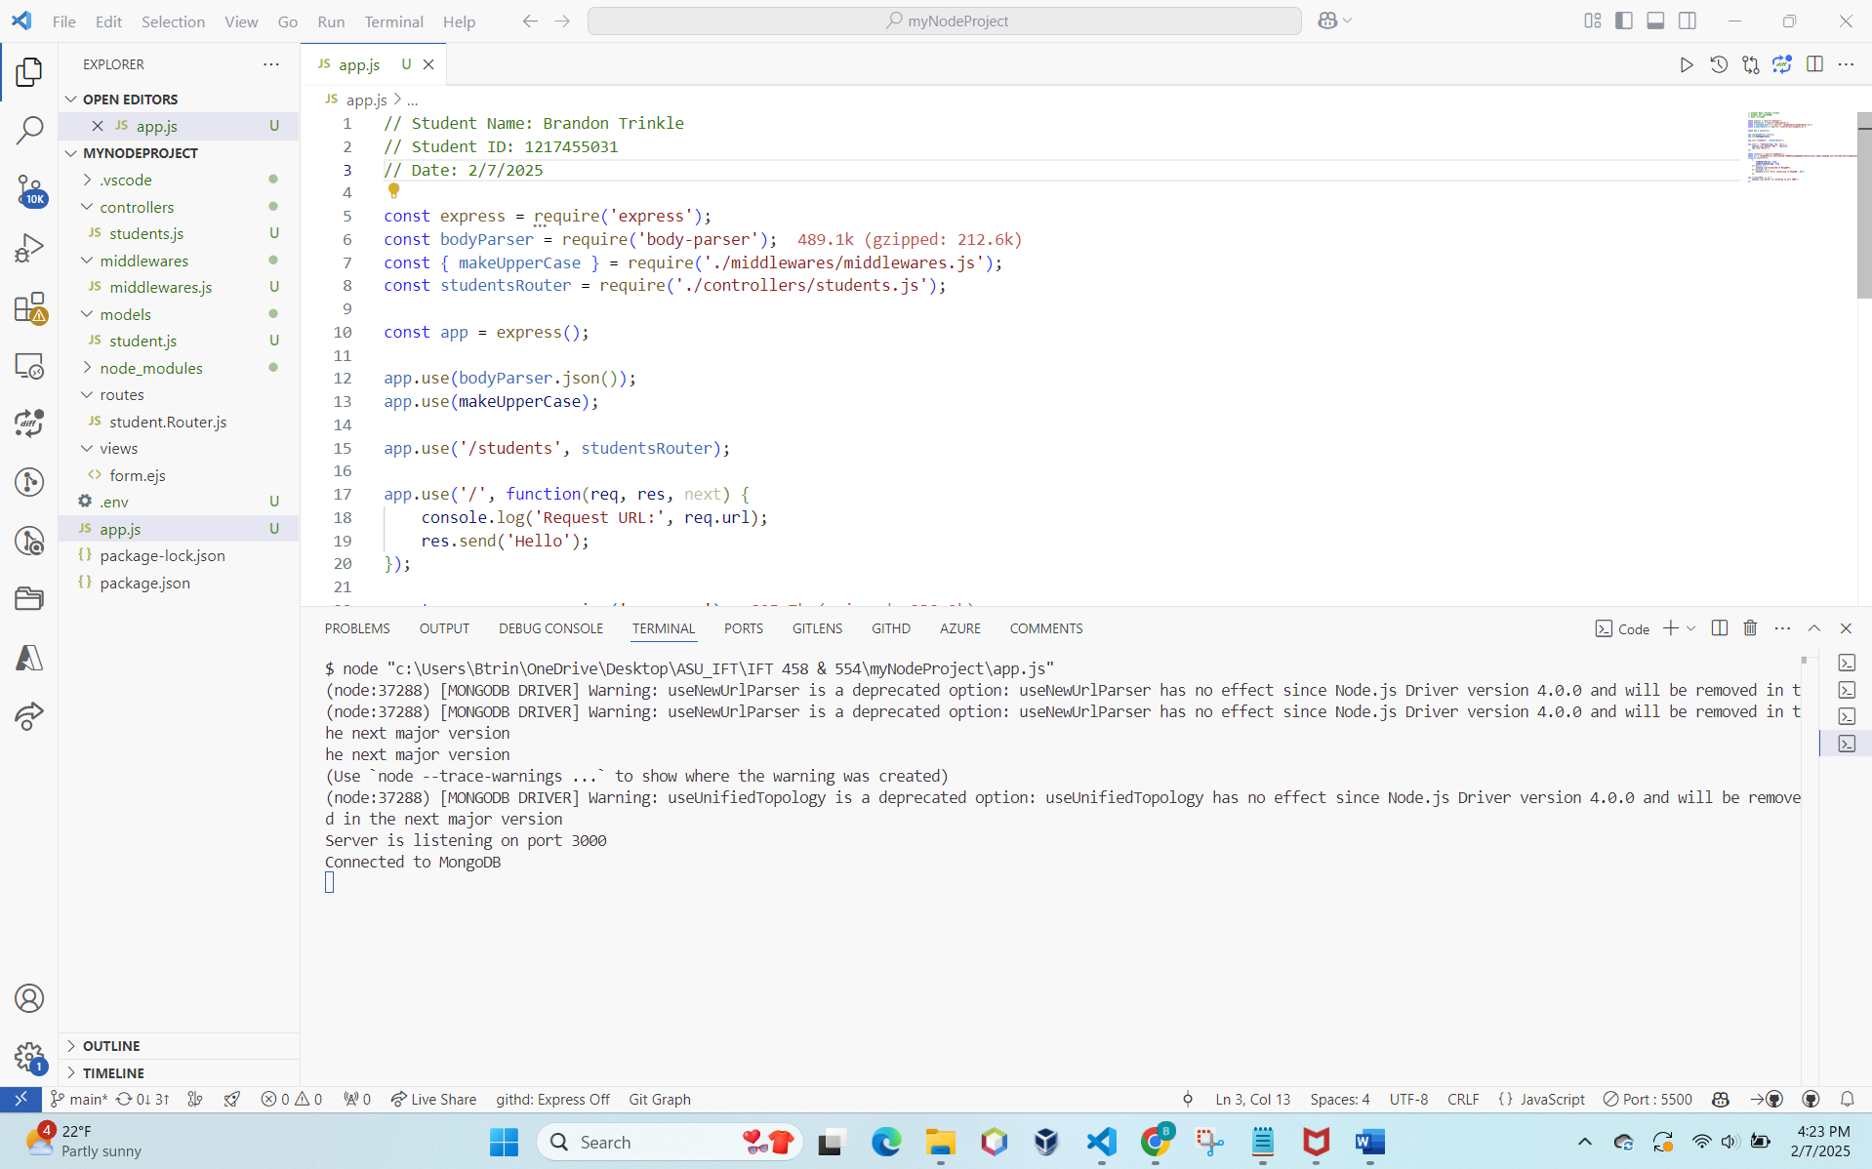*

*Note:*

* *Added logic to record connection to database (success or error)*
  + *Created an .env file to secure storage of username and password to the database*
  + *Unused because I’m not sure how strict we have to follow the code that is provided – so I kept it as how you had the code displayed.*
* *Downloaded the zip file from the lab – had required imports from the code provided.*
* *Student.js in the controllers directory required an entire refactor for the code provided to be successful.*
  + *The original code for students.js exported a function. In app.js we use an express router.*
  + *When running app.js it was failing when passing object function instead of a middleware function.*
* *Solved this by exporting routers instead of functions.*
* *This removed the functionality of the use of the form because we are not importing views anymore.*
  + *Was not an objective of this lab, just an observation I had. I assume we will handle this in future labs.*
    - *Localhost:3000 will not display the form anymore*